Kind regards / Mit freundlichen Grüßen

Damian Herms
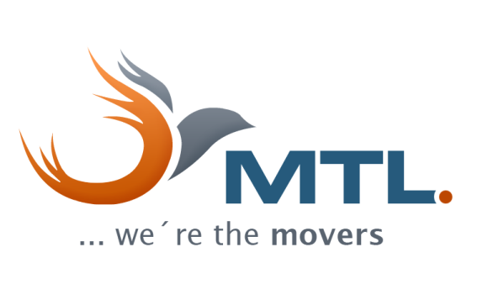 | MTL Moving  Transport Logistics e. K.  Dorn-Assenheimer Strasse 50  61169 Friedberg  Germany  www.mtl-moving.com  
Phone +49 (0) 6031 161 73 12  Mobile +49 (0) 172 148 7137  E-Mail damian.herms@mtl-moving.com  Managing Director: Aydın Yavuzyılmaz  Tax identification number: DE233711731  Amtsgericht Friedberg HRA 3913 | International Office Berlin  Malplaquetstrasse 22  13347 Berlin  Germany  Phone +49 (0) 30 2769 1676  e-mail berlin@mtl-moving.com
Unsere Datenschutzerklärung nach EU-DSGVO finden Sie unter https://www.mtl-moving.com/de/datenschutz/
Our data privacy statement in accordance with EU-GDPR may be found at https://www.mtl-moving.com/en/data-privacy/
SAVE PAPER - THINK BEFORE YOU PRINT

Please pay attention to the ongoing crisis in container shipping. Detailed information may be found here: https://bit.ly/2NGSrAY

