Kind regards / Mit freundlichen Grüßen

Damian Herms
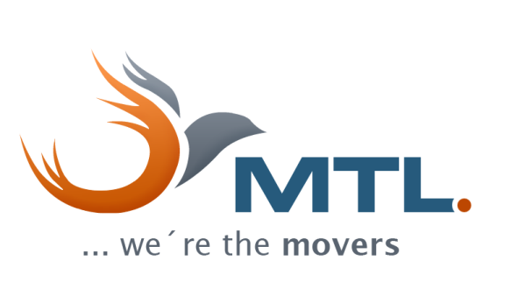 | MTL Moving  Transport Logistics e. K.  Dorn-Assenheimer Strasse 50  61169 Friedberg  Germany  www.mtl-moving.com  Phone +49 (0) 6031 161 73 12  Mobile +49 (0) 172 148 7137  E-Mail damian.herms@mtl-moving.com
NEU / NEW:  MTL International Office Istanbul  Imes Sanayi Sitesi, D Blok 401 Sk.  34775 Dudullu/Ümraniye/Istanbul  Turkey  Phone +90 530 403 8888  E-Mail move-tureky@mtl-moving.com | International Office Berlin  Sterkrader Strasse 49-59  13507 Berlin  Germany  Phone +49 (0) 30 2769 1676  E-Mail berlin@mtl-moving.com
Geschäftsführer: Aydın Yavuzyılmaz  Ust.-IDNr.: DE233711731  Amtsgericht Friedberg HRA 3913 | Datenschutzerklärung nach EU-DSGVO  Data Privacy Statement EU-GDPR  SAVE PAPER - THINK BEFORE YOU PRINT
Please pay attention to the ongoing crisis in container shipping. Detailed information may be found here: https://bit.ly/2NGSrAY


