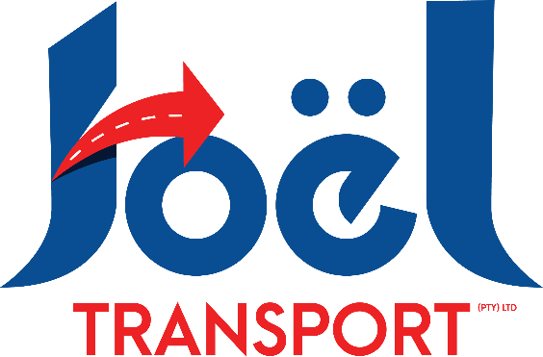

Thank you for your valued enquiry.

Sea/Airfreight – POE/APOE: Johannesburg

**Shipping Instructions:**

**Consignee:**

Full Name of Client (As per passport)

C/O Joel Transport (Pty) Ltd

10 Van Tonder Street

Sunderland Ridge

Centurion, 0157

Att: Lerato Mathabathe

Email: [lerato@joeltransport.co.za](mailto:lerato@joeltransport.co.za) Tel: +27 12 666 9055

**Notify Party:**

As per Consignee

Please wait for our greenlight before you dispatch. Please send draft BL(SWB) or AWB for approval prior.

**Documents Required:**

**Returning Citizens:**

Copy of the Seaway Bill(Telex release, if OBL)

Packing List

Affidavit – to be stamped at the nearest police station in SA

DA304

P1160

Clear Copies of the Passport – Photo page, Exit Stamp & Entry Stamp pages.

**Non Citizens:**

Copy of the Seaway Bill(Telex release, if OBL)

Packing List

Work Permit

DA304

P1160

Clear Copies of the Passport – Photo page & Entry Stamp page.

**Diplomats:**

Copy of the Seaway Bill(Telex release, if OBL)

Packing List

Certificate A or B

Clear Copies of the Passport – Photo page & Entry Stamp page.

Please Note:

The client must be in South Africa before the goods arrive for customs formalities to avoid unnecessary delays and additional charges.