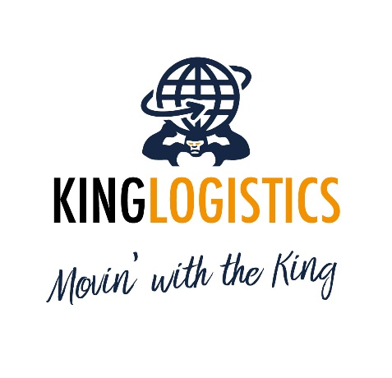

**Inclusions:**

* Import clearance
* Import THC
* Pick up from Port / Airport
* Transportation to final residence
* Unloading (normal access up to 1st floor)
* Full unpacking service, basic reassembly
* Removal of debris at time of delivery

**Exclusions:**

* X-ray exams
* Taxes and duties, any costs for customs inspections, demurrages, deconsolidation fees, customs warehouse, documents issued by customs offices, import clearance on new items, import clearance on abeyance duty, etc.
* Delivery over 1st floor residence, difficult access, long carry, stairs carry, shuttle service, external elevator, parking permits and reservation
* Reassembly of furniture that requires the specialist, settlement of contents, assembly new furniture pieces, handyman service, handling of heavy items
* Storage and warehouse handling, insurance coverage

**Kind regards,**

**Marta Rivolta**

Commercial Director

***King Logistics***

Via Polveriera, 41

20026 Novate Milanese (MI) – Italy

**Mobile: +39 351 952.78.22**

Phone: +39 02 270.17.574

Email: [m.rivolta@kinglogistic.it](mailto:m.rivolta@kinglogistic.it)

Website: [www.kinglogistic.it](http://www.kinglogistic.it)