Page 1 of 2

IMPORTANT

* Two Customs declaration forms must be completed in duplicate for unaccompanied articles.
  + Both forms must be submitted to the officials at the accompanied baggage inspection area upon arrival in Japan.
  + One is used as the Customs record and the duplicate will be returned with an official seal.
* This certified duplicate is required for clearance of the unaccompanied articles and shipments.
* In the event this form is not completed and certified by Customs officials upon entry, the shipment may be subject to duties and taxes.
* The Japanese Customs Forms are distributed in-flight to Japan by the airplane flight crew attendants.

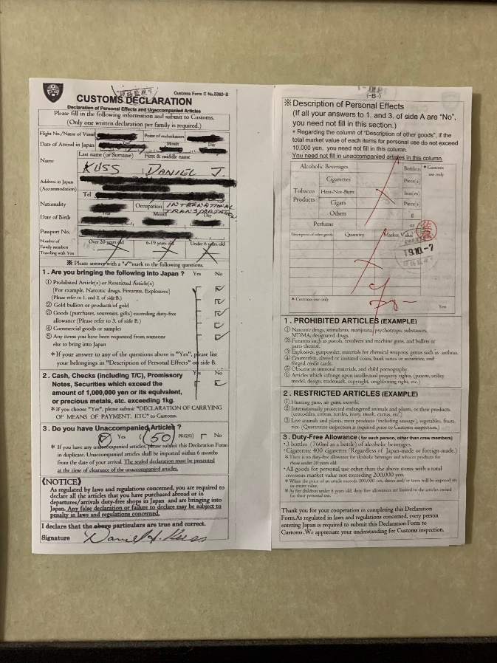

Page 2 of 2

