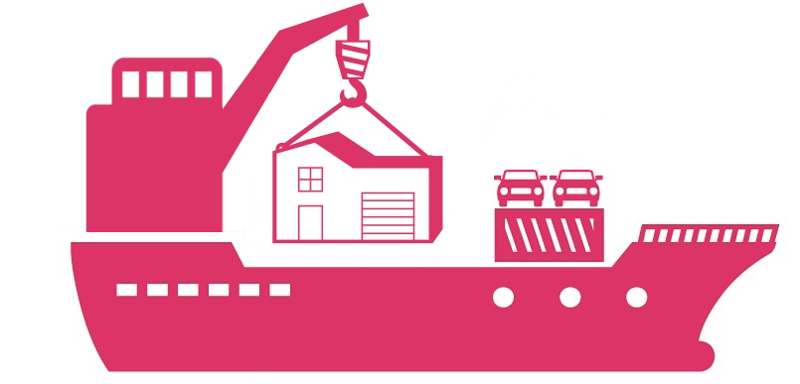DEMEWORLD

**LCL SHIPMENTS**

DESTINATION SERVICE INCLUSIONS / EXCLUSIONS

**LCL SHIPMENTS**

INCLUDED :

Import clearance, trucking to residence assuming normal access, delivery up to 2nd floor, box unloading on 1st flat surface, funiture set & unwrapping, simple reassembly (in the limitation of 3 items, no more than 10 min per item), disposal of debris.

EXCLUDED :

NOVCC & Port Charges (200 – 250 EUR/Cbm), custom exam (if any), import duty & taxes (if any), diffcult access, shuttling, outside lift (250 EUR / Half Day - 400 EUR/ Whole day), delivery upper than 2nd floor, heavy handling, box unpacking, complex reassembly, bank fees (40 EUR).

Kind regards,

|  |  |
| --- | --- |
| logo DEMEWORLDDEMEWORLD | Jeremy BOCCANERA |
| 19, rue d' Arsonval - 69680 Chassieu | General Manager /International Removalist |
| SIRET n° 84996490300017 | +33 (0)6 14 44 05 01 |
| EORI n° FR84996490300017 | [jeremy@demeworld.com](mailto:jeremy@demeworld.com) |
| TVA n° FR43849964903 | www.demeworld.com |