Destination services
POE: Miami / Everglades

Rates include:
Import customs clearance
Import customs formalities
Delivery to residence (up to 2nd floor)
Unloading, Unpacking of cartons onto a flat surface and removal of debris

Rates exclude:
THC at destination port
Demurrage & detention
Insurance
NVOCC/deconsolidation fee for LCL
Long carry or moving over 2nd floor via stairs
Parking permit

Additional charges general:
Shuttle service- $400
Car delivery- $450 (within 40 miles radius)
Motorcycle handling fee- $450 (not in crate)
Piano handling fee- $250
Long carry- Calculated as follows: CF x $0.15 x (distance/100). First 75 feet are always free.
Second day- $450 - $750
16’ truck (1 day rental)- $295
Extra drop-off stop- $175.00
Wooden crates- depending on size
Disposal fee- $250 for the first ton.
Heavy items- $55 per item over 200lbs
Elevator- $75

Extra charges:
LCL: full unpack $150 <200cf, plus $0.75 p/cf >200cf; consolidator
Pickup $175 ( up to 2 hours, after that additional $50 p/h )
FCL: full unpack for 20’, 40’, 40’ HC $0.75 p/cf; double handling for 20’ $450, for 40’ $650, and for 40’HC $750
Groupage: full unpack $150 <200cf, plus $0.75 p/cf >200cf; custom clearance p/client/ job $350; double handling if container loose additional
$200

** For deliveries out of FL please email us ** Please Note: Prices are based on different factors and therefore may change. Aragon will advise on any price change.

Kind regards

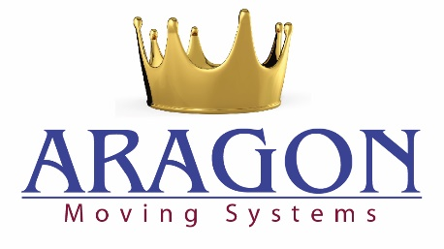 | Jamie Cohen  Operations Manager  P: 877-921-5678 EXT 112  WhatsApp: +1 332-287-8114  A: 2357 Stirling Road, Fort Lauderdale, FL 33312  Aragonmovers.com | Facebook | Twitter | Yelp! | HomeAdvisor

