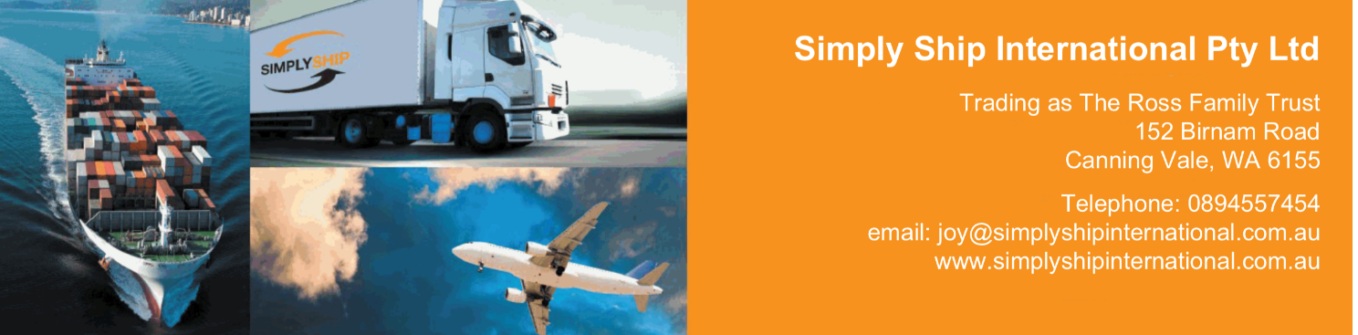

**Destination services**

**Rates include**

Import customs clearance

Import customs formalities

Delivery to residence (up to 2nd floor)

Unloading, Unpacking of cartons onto a flat surface and removal of debris at time of delivery only

**Rates exclude**

**Port Infrastructure fee**

THC at destination port

Demurrage & detention

Insurance

NVOCC/deconsolidation fee for LCL

Long carry or moving over 2nd floor via stairs

Parking permit

Excludes assembly of Ikea and kit furniture

**Additional charges**

Shuttle service: 10,- € / cbm

Handling heavy item 100 - 250 kg: 120,- € / piece

Assembling: 25,- € / hour / man

Debris removal later than delivery date: 80,- €

Kind regards,

Joy Ross

Simply Ship International

152 Birnam Rd, Canning Vale, 6155

Mob. +61 410386112

joy@simplyshipinternational.com.au

www.simplyshipinternational.com.au