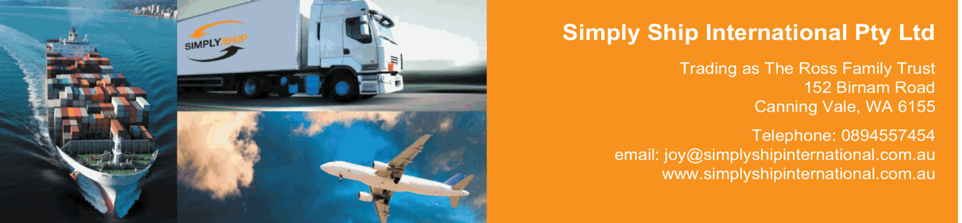

**Origin Services**

**Rates include**

Supply of new packing materials

Disassemble and wrapping of furniture

Preparation of the packing list

Transportation of the container to port of departure

Standard export custom clearance

**Rates exclude**

Parking permits request, taxes for parking permits

Shuttle services

Crating if necessary, collection of pianos, safes or any other object due to their special size or shape

THC at destination

Duties & taxes, custom clearance at destination, destination services and any other charge at destination.

Liftvans

**Additional charges**

Shuttle service: 10,00- € / cbm

Handling heavy item 100 - 250 kg: 250,00- € / piece

Parking permits request 100,00€

Kind regards,

Joy Ross

Simply Ship International

152 Birnam Rd, Canning Vale, 6155

Mob. +61 410386112

joy@simplyshipinternational.com.au

www.simplyshipinternational.com.au