Dear colleague,

Thank you for your kind rate request!

It’s a pleasure to send our **SPECIAL QUOTE** for this destination service. Many agents and customers have already enjoyed our quality service so we truly hope you could become part of our network of agents around the world.

With 21 years of experience, we are a leading mover in Ecuador, always providing a professional service to international organizations such as the Embassy of the United States, Embassy of Canada, Ecuadorian Embassies and Consulates all over the world, United Nations, IOM, etc.

**\*Please note the packing lists format required by Ecuadorian customs for non-diplomatic shipments:**

They must be made in Excel, in SPANISH, divided in five columns:

Column 1 (BOX/BULK Nº): Numbers in sequence.

Column 2 (CONTENT): Very detailed description of EVERY item that goes inside each box or bulk. General concepts such as miscellaneous, clothing, etc. are NOT admitted.

Column 3 (QUANTITY): Number of units per each item.

Column 4 (CONDITION): Define between NEW or USED.

Column 5 (VALUE IN USD $): referential value for each box or bulk.

Refer to example below:

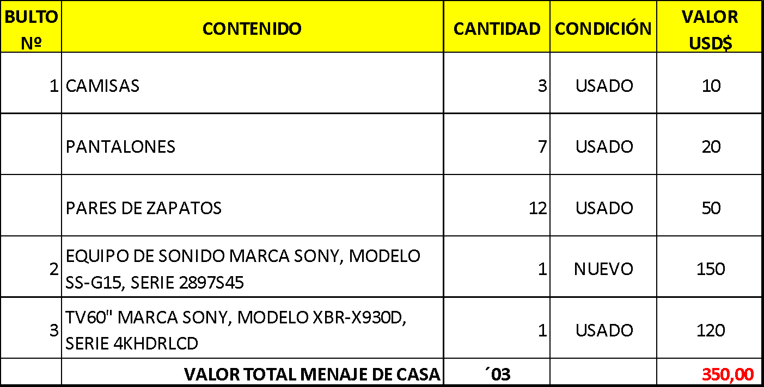

PLEASE NEGOTIATE 21 DAYS FREE OF CHARGES AT PORT OF GUAYAQUIL WITH THE SHIPPING LINE.

**\* Possible extra charges:**

Legal Affidavit/Sworn Statement (only for non-diplomatic shipments): **USD $150**

**\*CUSTOMS PRE - APPROVAL OF VEHICLES:** If the owner is an Ecuadorian citizen and NOT a diplomat, the shipper must fill out the vehicle’s specifications in a VEHICLE PRE-APPROVAL FORM and send it to Ecuadorian Customs.

Please ask us for these instructions if the customer is including a vehicle.

**\*Important aspects of shipments to Ecuador:**

* Every box must come with shipper’s name on it.
* Even if the content of a certain item is a gift or donation, the label of the bulk shouldn’t indicate so.
* Only diplomats and returning Ecuadorians are allowed to import vehicles.
* Non diplomatic shipments with MSC shipping line will generate extra local charges that are not included in our quote.

We look forward to working with you. Please feel free to contact us if you have any inquiries or suggestions, we’ll be happy to help.