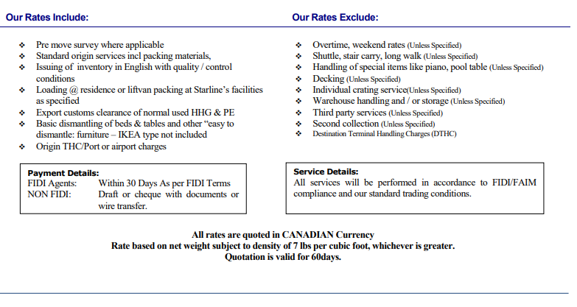 )air cartons not included)

Air and LCL freight rates include warehouse handling

Liftvans (US $350) and air cartons are not included in quoted rate

Warehouse handling (loose load only): Min: US $100 ($0.10 per lb)

Storage per month: Min: US $100- ($.07 per lb)

Local container P&D including scales: $650

Shuttle charges: $0.12 per lb

Long walk, stair carry or elevator: $0.07 per lb

Mileage: $3 / running mile

Overnight charges: $400 per night

Weekend / Holiday service: $.07 per lb ($300 min)

Upright & Grand Piano handling: $275 & $350

TV CTN: $180/CTN

CTN delivery: $100

Additional pick up: $150



