Rates inclusion
1,Customs clearance
2, Application for Import permit (if Working Permit has been issued in Shanghai, Beijing or Guangzhou)
!!! Please let us know if the Working Permit is to be issued from another location than one of these 3 cities !!!
3,Line haul
4, Final delivery within city limits (within 50kms radius)
5, Full unpacking and standard furniture reassembling
6, Clean the debris after delivery (on delivery day)

Rates Exclusion
1,Destination Terminal Handling Charge / De-consolidation Charge / NVOCC
2, Port demurrage Charge .
3,Customs import taxes and duties .
4, Customs Inspection fee (if applicable)
5, Bonded warehouse storage charges
6,Parking fees/permits .
7, Services requested outside of normal working hours or during public holidays
8,Extra charges due to difficult access (shuttle, stair carry, long carry, parking access, hoisting…)
9,Any not required additional service (storage, maid, electrician, handyman…)
10,Handling of heavy and/or large items such as pianos, stone statues, safe…
11,Reassembling of complex furniture that should require 3rd party intervention
12,Disbursement fees (any charges paid on your behalf will be invoiced back at cost plus 6%, min. US$80.00)
13, Please add US$30.00 for bank fees

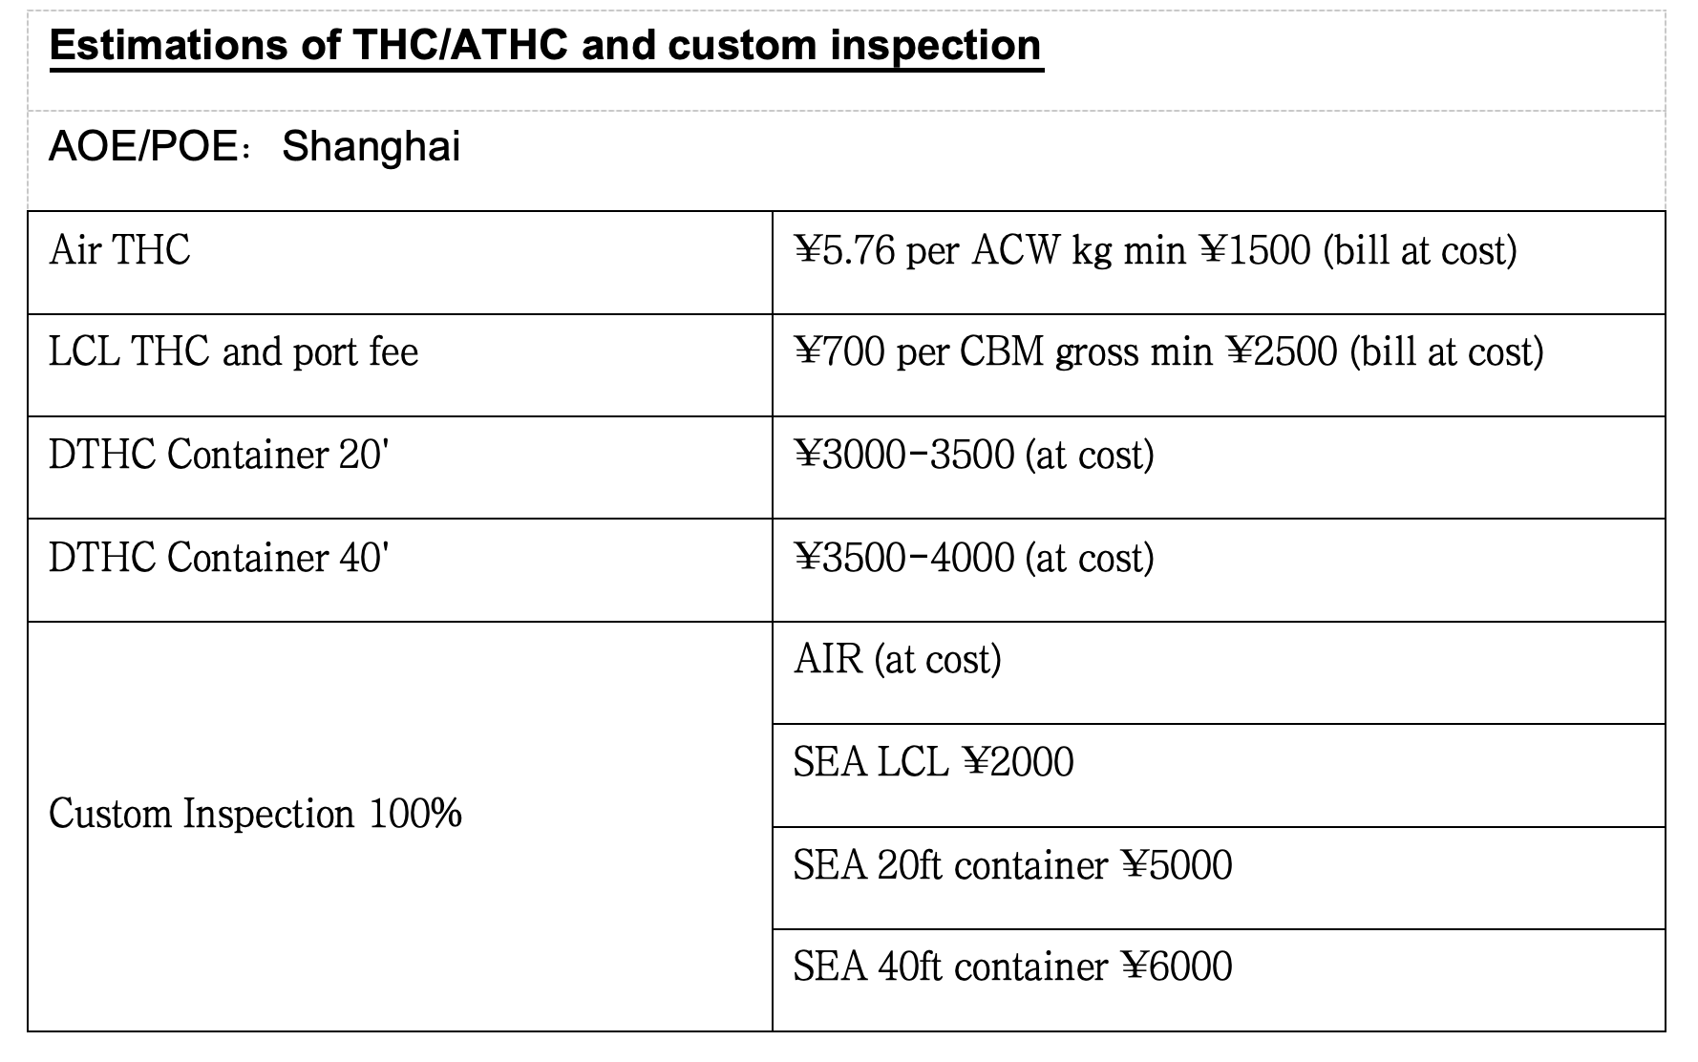

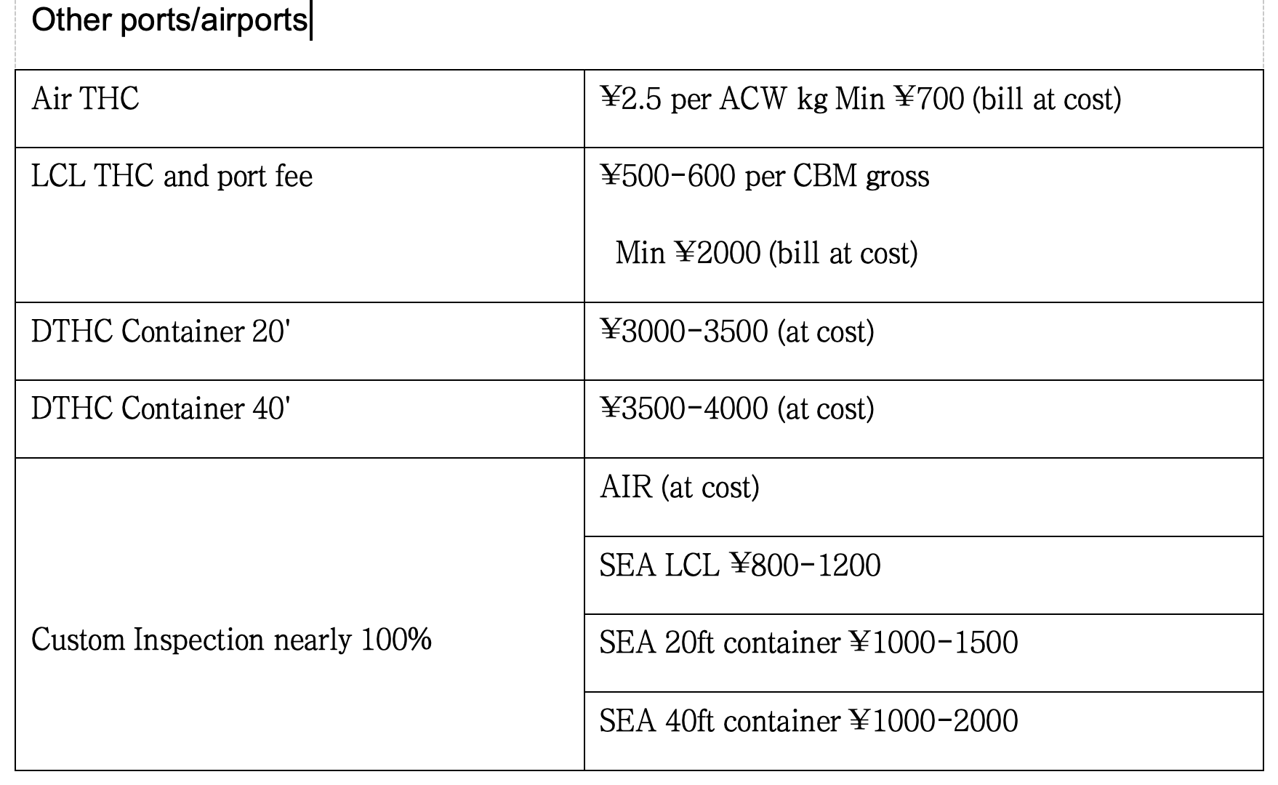

We recommend that all the THCs and associated charges be prepaid.
All destination terminal (DTHC/NVOCC) and port fees are ESTIMATED

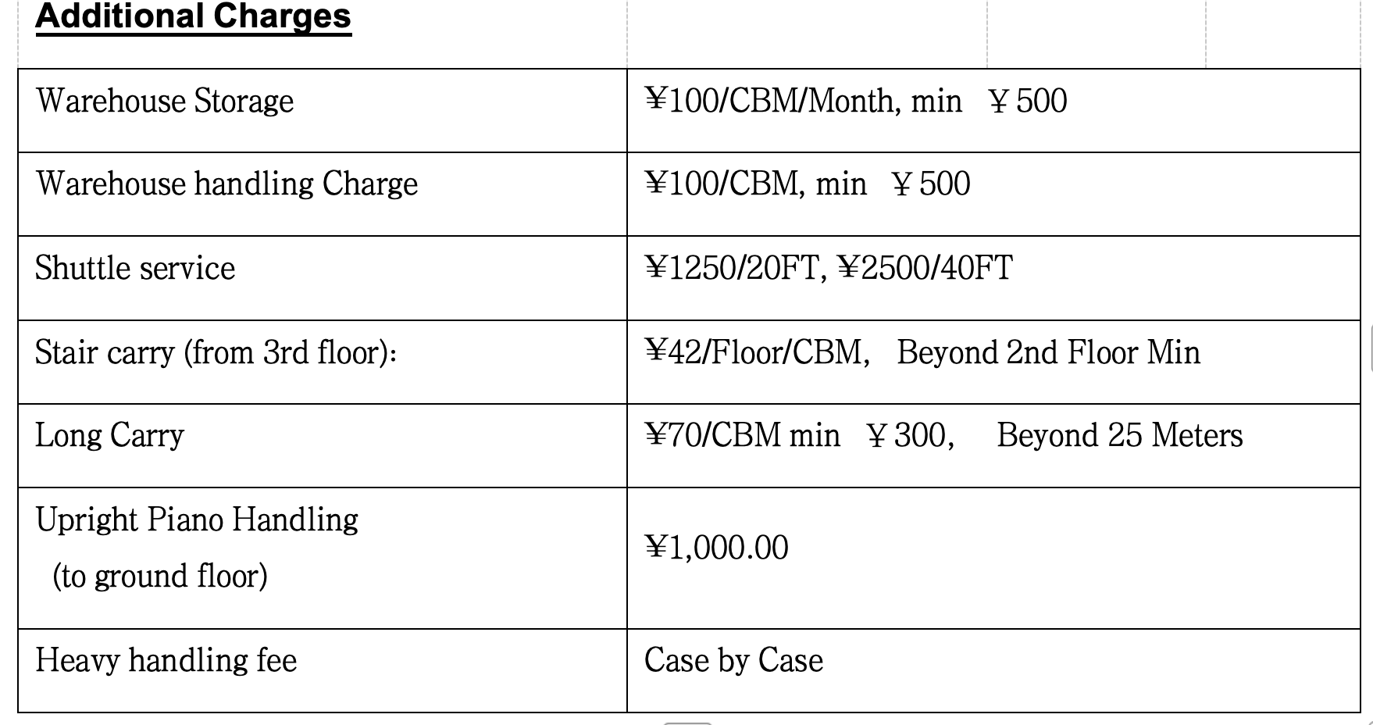

Documents Required for Foreign passport holders
1. Original Passport with residence permit valid at least for 12months
2. Original Alien Working Permit / Electronic work permit (with a validity at least 365 days)
3. Employment Approval Letter issued by the Foreign Expert Bureau (Required in Beijing).
4. Representative Card (required for foreign representative office).
5. Detailed Inventory
6. Ocean Bill of Lading/AWB
7. Application Form with signatures and company's chop** (chop can be waived for some cities)
8. Authorization Form for import Personal Effects**
9. Airport Baggage Declaration Form stamped by Chinese customs officer (sometimes can be waived)
10. Electrical items with model, serial number & size /Furniture list with material
**Provided by SAE

Documents Required for Returning Chinese(must be import within 6 months after client’s arrival in China_
- Original passport
2. Original foreigner residence permit/Visa showing a stay of at least 365days abroad (or more than 6 months in the case of an air shipment).
3. Chinese identity card (Shen Fen Zheng)
4. Detailed Inventory
5. Ocean Bill of Lading/AWB
6. Company letter issued by employer in China (sometimes can be waived)
7. Airport Baggage Declaration Form stamped by Chinese customs officer
8. Copy of the client's property deed or rental contract in China.
9. A printout of the client`s entry record into mainland China for the last 3 years (issued by the PSB)
10. Application Form with signatures**
11. Authorization Form for import Personal Effects**
12. Electrical items with model, serial number & size /Furniture list with material
**Provided by SAE

Documents Required for Taiwan/Hongkong/Macao Residents
1. Mainland Travel Permit for Taiwan Residents/ Hong Kong and Macao residents (Tong Xing Zheng)
2. Chinese residence permit (Ju Zhu Zheng)
3. Detailed Inventory
4. Ocean Bill of Lading/AWB
5. Application Form with signatures and company's chop** (chop can be waived for some cities)
5. Authorization Form for import Personal Effects**
6.Airport Baggage Declaration Form stamped by Chinese customs officer (sometimes can be waived)
7. A printout of the client`s entry record into mainland China for the last 2 years (issued by the PSB)
8. Electrical items with model, serial number & size /Furniture list with material
**Provided by SAE

Sea shipment: import clearance normally takes 2–3 weeks.
Air shipment: import clearance normally takes 4-8working days

Consignment Instructions
Consignee:
Client' Passport Full Name
C/O SAE RELOCATION Co., Ltd.
Room 18HI, 99 Huaihai East Road
Huangpu District, 200021 Shanghai, CHINA
Attn.: Yuki Tian
Tel: +86 21 53018200
Email: yuki.tian@saerelo.com

Notify: Same as consignee
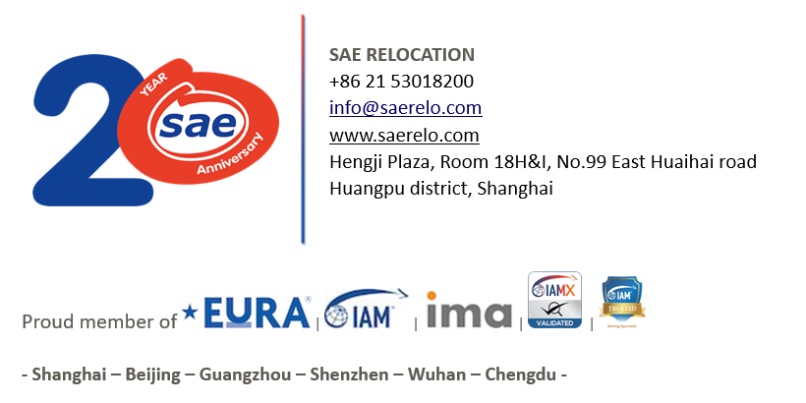
Description: Used Household goods & Personal Effects.

