Rates Include:

Import customs clearance, Import customs formalities, Destination Terminal Handling Charges for FCL, Container trucking, Delivery to residence (up to 2nd floor), Unloading, unpacking of cartons onto a flat surface, Reassembling of furniture except IKEA, new furniture, furniture requiring handyman, Removal of debris, Shuttle service,

Rates Exclude:

BAF, CAF, EBS charges from shipping line, Demurrage and detention, Insurance,

NVOCC/deconsolidation fee for LCL (USD 100 to USD 150 per cbm), Container returning fee (if shipping line requests), External elevator, internal lift car – Until 10th floor (USD 150) above 10th floor (USD 250), Long distance charges (if other destination area)

Additional Services (contact us):

Upright piano, Baby grand piano, Vehicles, Storage

Thank you, En vous remerciant, 감사합니다.

Best regards.

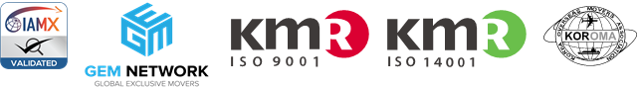[](http://www.glskorea.kr/)[](http://www.moverspoe.com/pricinglogin.aspx?ReceiverID=M64786)

