TERMS, CONDITIONS & SCOPE OF SERVICES

Important Notice – Free Time / Demurrage Protection
FCL Shipments (Full Container Load)
To avoid potential demurrage, detention, and port storage charges, we strongly recommend purchasing a minimum of 12 days' free time at the time of booking.
Any demurrage, detention, storage, or related charges incurred due to insufficient free time will be for the consignee's account.

Scope of Services Included
Our quotation includes the following services:
✓ Customs clearance documentation and processing under normal import procedures
✓ Port terminal handling charges (DTHC) (FCL Shipment only )
✓ Collection of the shipment/container from Port Louis Harbour
✓ Transportation from port to the delivery residence
✓ Unloading of household and personal effects
✓ Unpacking of furniture and household goods
✓ Placement and positioning of standard furniture items
✓ Removal of packing materials and debris on the day of delivery
✓ Return of the empty container to the designated depot (FCL shipments)

Services Excluded
Unless specifically stated otherwise, the following charges and services are excluded from our quotation.

Port, Terminal & Storage Charges
- Demurrage charges
- Port storage charges
- Container detention charges
- Bonding fees
- Customs examination fees
- Government inspection fees
- Any charges imposed by shipping lines, port authorities, or terminal operators

Customs & Government Charges
- Customs duties and taxes
- VAT or other applicable government levies
- Government penalties or administrative charges
- Any fees imposed by Mauritius Customs or other regulatory authorities

Additional Delivery Services
- Shuttle service where container access is restricted
- Delivery above the first floor without suitable elevator access
- Long carry from vehicle parking position to residence
- Split deliveries to multiple addresses
- Redelivery due to consignee unavailability

Special Handling Services
- Pianos
- Safes
- Marble or stone items
- Oversized or exceptionally heavy items
- Crane services
- Specialist lifting equipment
- Uncrating services

Installation & Handyman Services
- Disconnection or reconnection of electrical appliances
- Plumbing works
- Electrical works
- Mounting or hanging of mirrors, artwork, televisions, curtain rails, shelving, etc.
- Assembly of modular furniture requiring specialist tools or third-party installers

Maid Services
- Placement of items into cupboards, wardrobes, cabinets, or shelving
- Arrangement of clothing, kitchenware, books, decorative items, or household contents

Insurance
- Transit insurance
- Storage insurance
- Marine cargo insurance

Warehouse Charges (If Required)
Should warehouse storage become necessary due to delivery restrictions, customer request or circumstances beyond our control, the following charges will apply:
Service | Rate
SDI Warehouse Handling In | USD 2.50 per CBM
SDI Warehouse Handling Out | USD 2.50 per CBM
SDI Warehouse Storage | USD 0.40 per CBM per day
These charges will be invoiced separately if incurred.

Customs Clearance Requirements – Mauritius
All documents required for customs clearance should be received at least five (5) working days prior to vessel arrival in Mauritius.
Provided all documentation is complete and compliant, customs clearance generally requires approximately five (5) working days.
Please note that Mauritius Customs may select shipments for physical examination or verification. In such cases, additional clearance time and related charges may apply.

Returning Diplomats
Returning diplomats may qualify for duty-free importation of personal and household effects, subject to the presentation of an official Duty Exemption Letter issued by the Ministry of Foreign Affairs of Mauritius.

Required Documents – Expatriates
The following documents are generally required for customs clearance:
- Copy of passport (photo page)
- Residence Permit or Occupation Permit
- Detailed inventory list
- Passport showing the last date of arrival into Mauritius

Dependents
Where the shipment contains goods belonging to dependents, copies of the following documents are also required:
- Passport
- Residence Permit / Dependent Permit
- Supporting immigration documentation issued by Mauritian authorities

Returning Mauritian Citizens
Returning Mauritian citizens are required to obtain a Passport Memo from the Passport and Immigration Office after arrival in Mauritius.
This document is required by Mauritius Customs to process duty-free clearance applications for household and personal effects.
Applications should be submitted as soon as possible following arrival.

Duty-Free Eligibility Conditions
To qualify for duty-free importation of household and personal effects, the following conditions must generally be satisfied:
- The individual must not have resided in Mauritius for more than six (6) months immediately prior to returning.
- The shipment must arrive in Mauritius within six (6) months of the consignee's last arrival date.
- A Passport Memo (for returning Mauritian citizens) or other supporting immigration documentation may be required.
Failure to meet these conditions may result in Customs duties and taxes being assessed by Mauritius Customs.
Please note that the final determination of duty-free eligibility rests solely with Mauritius Customs.

Additional Delivery & Special Handling Charges (If Applicable)
The following charges apply where required and are not included in our standard quotation:
Service | Rate
Shuttle Service (restricted access) | USD 150.00 per 20' container / USD 250.00 per 40' container
Delivery above 1st floor (no elevator access) | USD 5.00 per CBM
Long Carry (over 30 metres) | USD 8.00 per CBM
Additional Porter | USD 40.00 per porter
Crane Service | USD 350.00 – USD 600.00 per operation
Piano Handling | USD 400.00
Motor Vehicle / Motorcycle / Pleasure Craft Handling | USD 600.00
Charges are subject to confirmation following a site survey or delivery assessment and may vary according to accessibility, dimensions, weight, and handling requirements.

LCL Shipments – Destination Charges & Conditions

Charges Excluded from Our Quotation

Standard Charges (If NOT Prepaid at Origin)
NVOCC / Deconsolidation / CFS Charges
USD 145.00 per CBM
(Includes destination deconsolidation, CFS handling, and co-loader processing charges.)

If Destination Charges Are Prepaid at Origin
Only the following charges are generally payable at destination:
- Documentation Fee
- Delivery Order Fee
Approximate cost: USD 120.00 (flat charge)

LCL Exclusions
The following are not included in our rates:
- Customs duties and taxes
- CFS Storage Charges – Approx USD 3 per day after 5 free days
- Government fees and levies
- Demurrage, detention, and port storage charges
- Cargo insurance
- Fumigation (if required)
- Customs inspection fees
- Warehouse storage and handling
- Shuttle service
- Split deliveries
- Third-party assembly services
- Long carry or stair carry charges
- Special handling of heavy items (pianos, safes, etc.)
- Crane services
- Any additional charges imposed by Customs, port authorities, shipping lines, or other government agencies

CFS Storage
A maximum of five (5) free days is generally available upon unloading into the CFS depot, And additional storage charges of USD 3 per CBM per day will be applicable after the 5 free days .
Same to be billed at cost to client or Origin Agent.

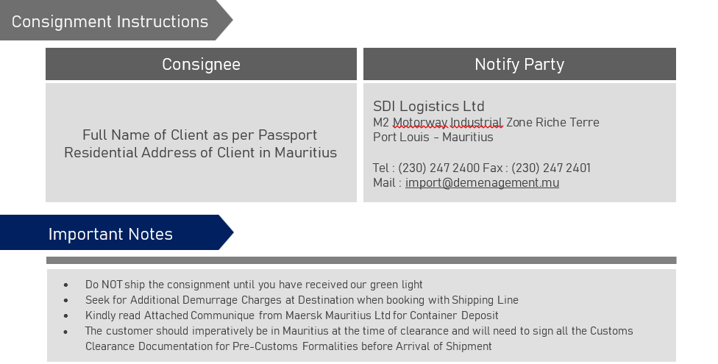

Rate Valid up to December 2026

Kind regards
SDI Import Move Coordinator
Email add: Import@demenagement.mu