**DESTINATION SERVICE RATE**

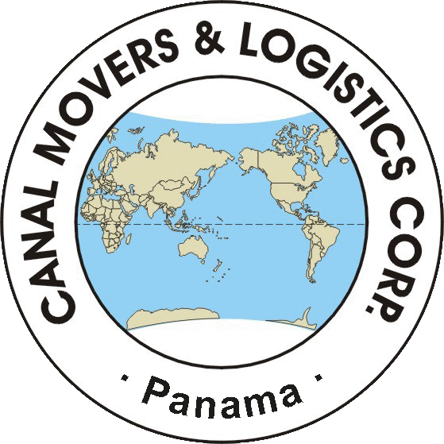

**Canal Movers & Logistics Corp.**

**P.O. Box 832-2457 World Trade Center, Panama City, Panama**

**Carmen Marrero**

**Tel: +507.232.5189 Fax: +507.232.5181**

Thank you for allowing Canal Movers & Logistics to submit our quote for destination services. Our rates are:

**Minimum weight: AIR: 3,000 lbs gross / LCL: 3,000 lbs net / 20’ = 5,000 lbs / 40’ ST or 40’HC=10,000 lbs**

**RATE VALID UP TO 60 DAYS**

**Remarks: Additional charge** of **$200.00 flat (per FCL)** if we have to pick up the container at the port of PSA Terminal (Pacific Coast) “or” at the ports of Cristobal, Manzanillo Int’l Terminal or Colon Container Terminal (Atlantic Coast, 50 miles from Panama City). **We recommend as POE Port of Balboa “or” Panama City Terminal to avoid these additional charges.**

**NOTE:** Please consider that our rates **are not flat rates**; they may vary according to final weight, size, and special service.

|  |  |
| --- | --- |
| **Rate includes** | **Rates Excludes** |
| * Normal Customs Clearance. * Pick up at the port of entry for Air, LCL and FCL. * Delivery for Normal access. * Delivery to residence (up to 2nd floor). * Unloading. * Unpacking / Uncrating. * Placing of Furniture. * Assembly of furniture’s that does not require third party services. * Removal of debris on the same day of delivery. | * Duties & taxes if applicable. * Terminal Handling Charge (THC) **per container.** * Container detention (after 7 free days). * 15% surcharge on any cash outlay. * Airport and Port Charges (demurrage, storage, inspection, etc.) * Customs Inspection at origin or destination. * Storage per month or fraction at **$5.00 per 100 lbs** / warehouse handling at **$10.00 per 100 lbs** (*one-time fee*). * Delivery out of storage within Panama City limits at **$250.00 Flat.** * Long distance carry at **$6.00 per 100 lbs.** * Stair carry above a second floor (*in absence of an elevator*) at **$3.00 per 100 lbs.** * Elevator charge (apply for deliveries at buildings) at **$3.00 per 100 lbs (minimum rate USD100.00).** * Shuttle service due to difficult access of **$6.00 per 100 lbs (minimum rate USD200.00).** * Hoisting, painting hanging, connection of electric or electronic appliance (equipment, lamp, ceiling fans). * Insurance for cargo, transportation, handling, etc. * Handling heavy items such as safe, piano, pool table, insurance, second deliveries, etc. |

|  |  |
| --- | --- |
| **Airport / Port charges** | |
| **Air shipments** | * Air drayage and Airport handling **per chargeable weight:** * 0 kg - 499 kg **no charge** * 500 Kg - 999 Kg **$200.00 Flat** * 1,000 Kg - 1,999 Kg **$250.00 Flat** * 2,000 Kg or more **$450.00 Flat** * **4,000 kg or more $450.00 Flat min. plus $250.00 per additional trip.** |
| **Land shipments** | * Storage at bond (if apply). |
| **(Sea) LCL shipments** | * Terminal Handling Charge (THC) of approx. * **$500.00-$650.00** for a 2-5 cbm shipment. * **$650.00-$1350.00** for a 6-12 cbm shipment. |
| **FCL shipments** | * Terminal Handling Charge (THC) of approx. * **$300.00** per FCL, **when NVOCC is used this charge may be double** * Container detention **(FCL)** (after 7 free days) of approx. * **$100.00 per day.** |

**Most shipping lines give us a free detention period of 7 days so additional charges are most likely to be incurred. Any detention charges will be billed to the booking agent unless instructed otherwise prior to the arrival of the container at the port.**

**Payment Terms:** Non FIDI or LACMA members must make payment in advance before release of the shipment.

Insurance is not included, and Canal Movers & Logistics Corp. cannot be held responsible for any eventual damage/loss to the shipment. With the acceptance of this rate it is automatically confirmed that the insurance you arrange for the transportation of this move waives all liability of reimbursement against Canal Movers & Logistics Corp., including handling, packing, transportation, warehousing, unpacking, maneuvering, and/or any other operation performed under their responsibility or that of its agents or sub-contractors.

|  |  |
| --- | --- |
| **Shipment must be consigned as follows:** | Client´s name as passport  c/o Canal Movers and Logistics Corp.  Bldg 1067, Curundu Road, Curundu  Panama City, Panama.  <Tel:507-2325189>  Fax:507-2328101  **( jointly and severally with… instead of C/O, in case you use MSC)**  Notify:  Canal Movers and Logistics Corp.  Bldg 1067, Curundu Road, Curundu  Panama City, Panama.  <Tel:507-2325189>  Fax:507-2328101 |

**Do not ship until green light is granted. OBL must be rated.**

**Vehicles:**

Our quote includes:



Ro/Ro:



**Please Note: There are additional charges for vehicles imported via Atlantic Coast POEs**

**Accessorial Services (Note:** *All accessorial charges have a* ***$50.00*** *minimum charge):*

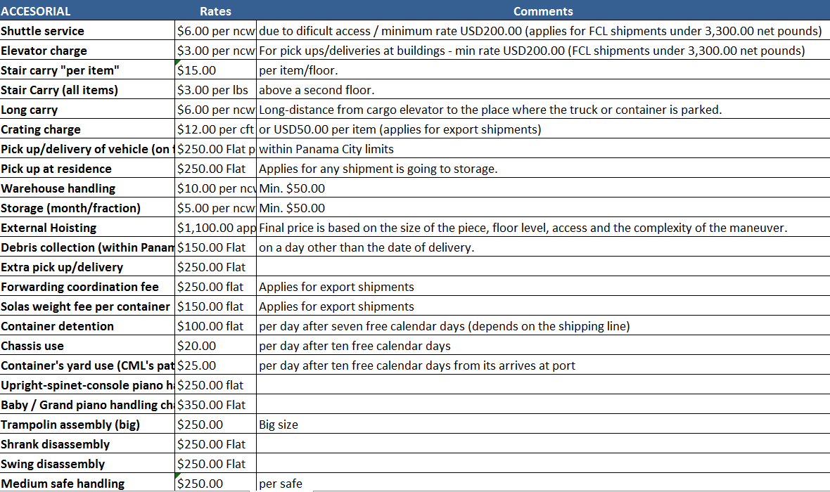

**We also offer:**

|  |  |
| --- | --- |
|  | ***Fully Integrated Relocation Solutions:*** Home Search, School Search, Cross-cultural Training, Orientation Programs, Temporary Accommodations, Language Lessons Referrals, Welcome / Information Kit, Pet assistance, insurance, immigration visas / documentation, Legal Assistance Referrals, Airport Transfers, etc. Web page: [www.larmgroup.com](http://www.larmgroup.com) Email: [panama@larmgroup.com](mailto:panama@larmgroup.com). |
|  | ***Furniture Rentals:*** We would also like to draw to your attention Canal Movers & Logistics Corp short-term furniture rental division. This allows your clients to live in the comfort of their own home while their goods are in transit – and actually save money. Web page: [www.panamafurniturerent.com](http://www.panamafurniturerent.com) Email: [info@panamafurniturerent.com](mailto:info@panamafurniturerent.com). |