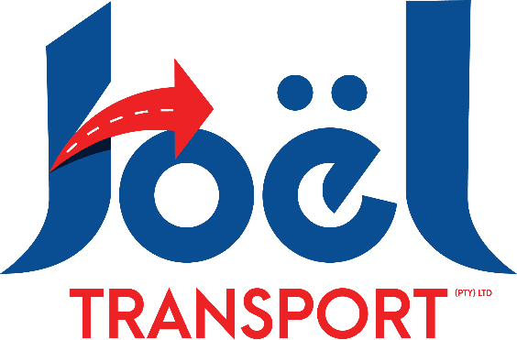

Thank you for your valued enquiry.

Sea/Airfreight – POE/APOE: Johannesburg
Shipping Instructions:
Consignee:
Full Name of Client (As per passport)
C/O Joel Transport (Pty) Ltd
10 Van Tonder Street
Sunderland Ridge
Centurion, 0157
Att: Lerato Mathabathe
Email: lerato@joeltransport.co.za Tel: +27 12 666 9055

Notify Party:
As per Consignee
Please wait for our greenlight before you dispatch. Please send draft BL(SWB) or AWB for approval prior.

Documents Required:

Returning Citizens:
Copy of the Seaway Bill(Telex release, if OBL)
Packing List
Affidavit – to be stamped at the nearest police station in SA
DA304
P1160
Clear Copies of the Passport – Photo page, Exit Stamp & Entry Stamp pages.

Non Citizens:
Copy of the Seaway Bill(Telex release, if OBL)
Packing List
Work Permit
DA304
P1160
Clear Copies of the Passport – Photo page & Entry Stamp page.

Diplomats:
Copy of the Seaway Bill(Telex release, if OBL)
Packing List
Certificate A or B
Clear Copies of the Passport – Photo page & Entry Stamp page.

Please Note:
The client must be in South Africa before the goods arrive for customs formalities to avoid unnecessary delays and additional charges.

