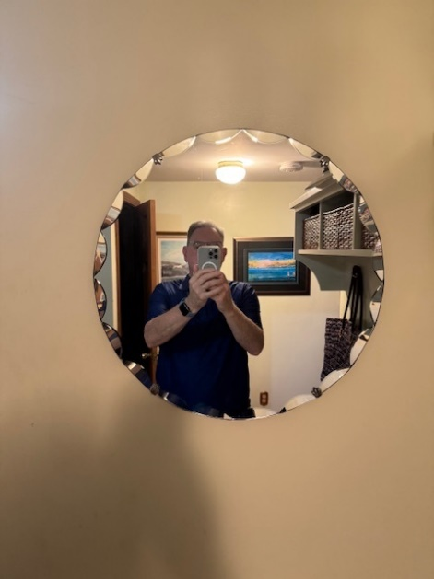 ROUND MIRROR 18 X 18 X 1

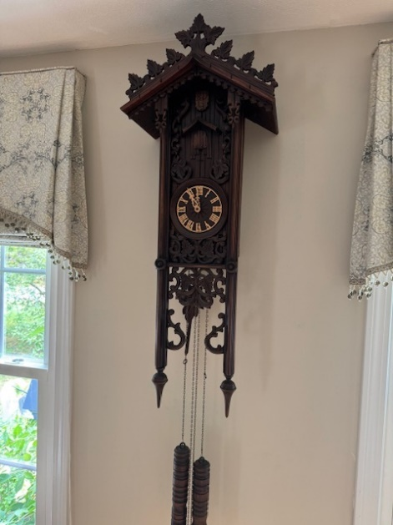 CUCKOO CLOCK 30 X 20 X 15

 36 X 18 X 10